Use ai to make proposal

me
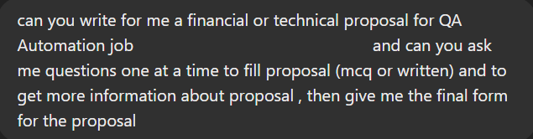

( First question) ai

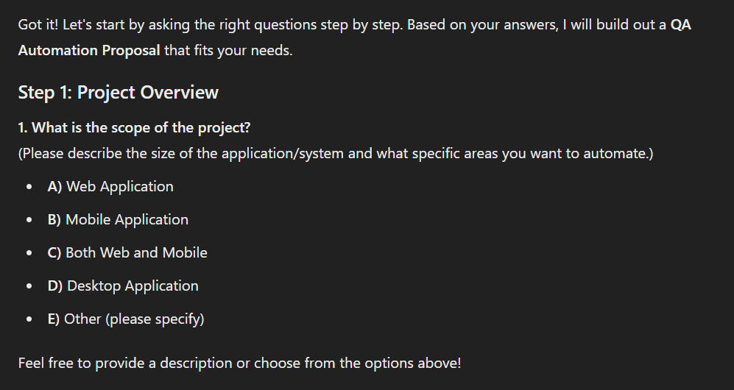

me

Ai (second question)

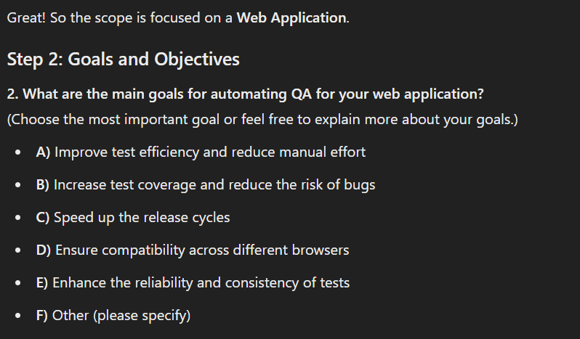
User

Ai (3 question)

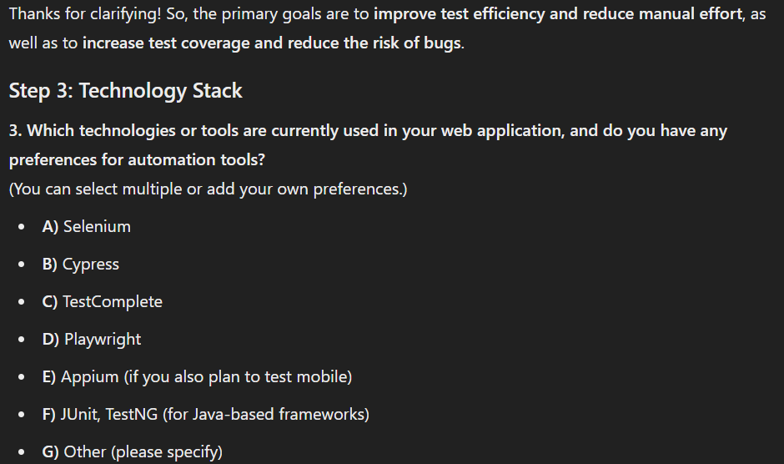
User

Ai (4 question)
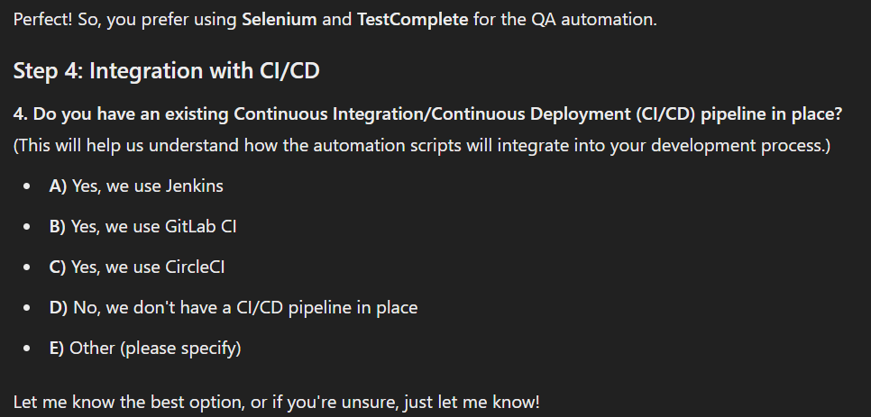
User

Ai (5 question)
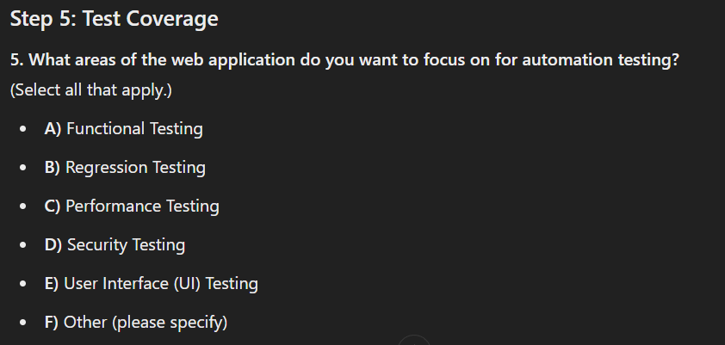
User

Ai(6 question)
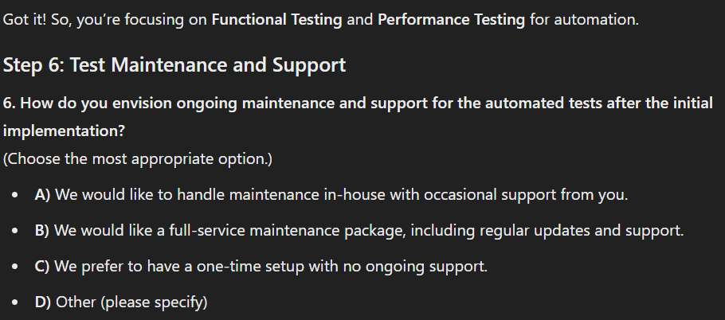
User

Ai question7
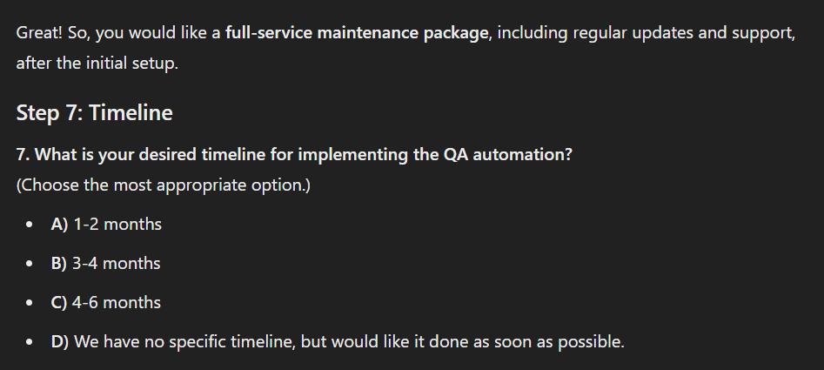

User



Ai question 8 and user answer
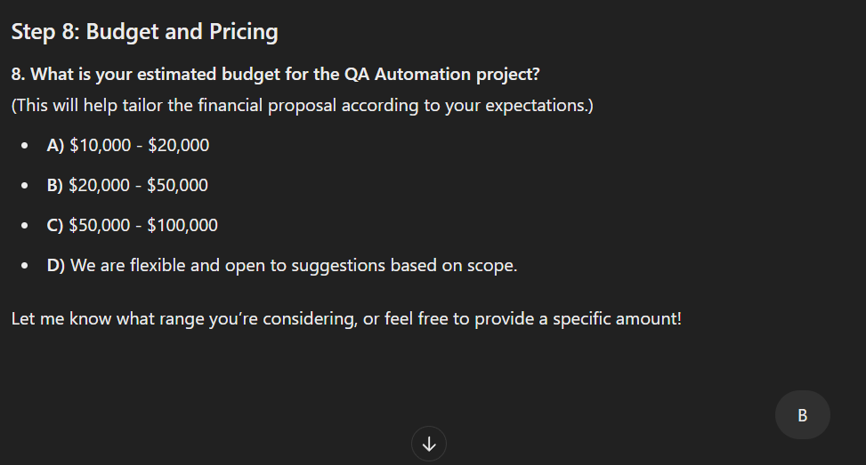
Ai (question 9) and user answer
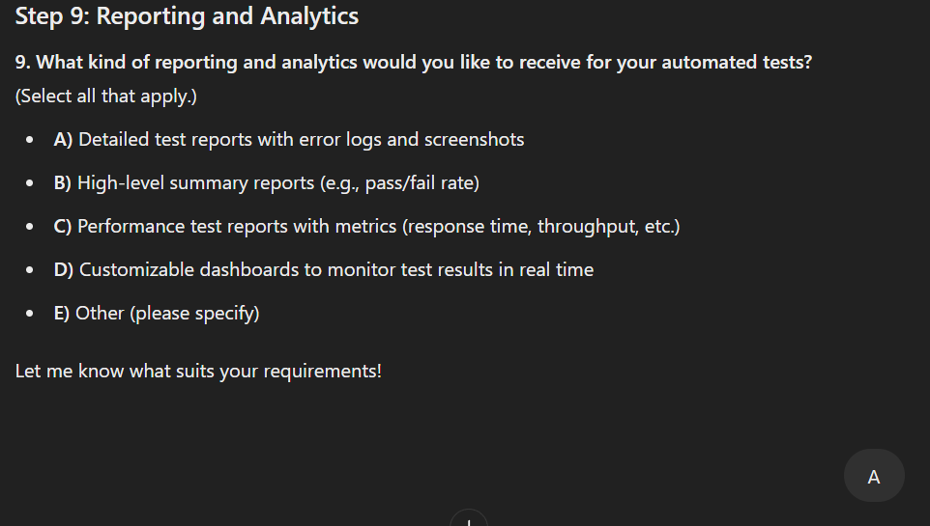
Ai (final question) and user answer
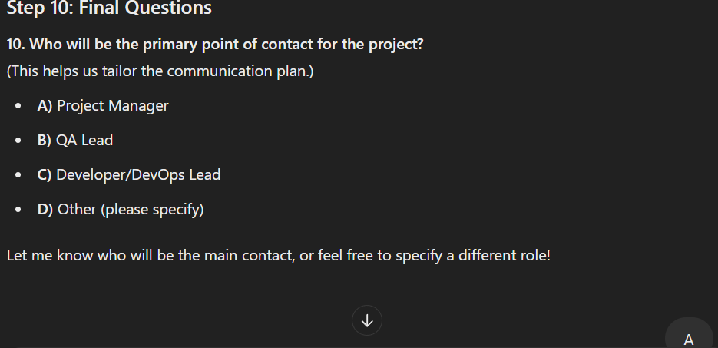
Ai final form proposal

QA Automation Proposal
1. Executive Summary
This proposal outlines the approach for implementing Quality Assurance (QA) Automation for [Client's Company Name], focusing on a web application. The goal is to enhance functional testing and performance testing through automation, increasing efficiency, reducing manual efforts, and improving test coverage to reduce the risk of bugs. This automation will be integrated with the existing CircleCI pipeline and maintained under a full-service support package for long-term success.

2. Objectives
The key objectives of this QA Automation project are:
1- Improve Test Efficiency and Reduce Manual Effort: Automate repetitive test cases to free up resources for more complex tasks.
2-Increase Test Coverage and Reduce Risk of Bugs: Ensure more comprehensive test coverage by automating critical functional and performance tests.

3. Scope of Work
1-Test Automation Strategy Development: Analyzing your current testing processes and identifying areas where automation can have the most impact.
2-Test Case Automation: Automating functional and performance tests using Selenium and TestComplete.
3-CI/CD Integration: Integrating automated tests into your CircleCI pipeline for seamless execution during code commits and deployments.
4-Maintenance and Support: Ongoing maintenance of automated test cases with regular updates and support, ensuring tests remain relevant as your application evolves.

4. Technologies and Tools
1-Test Automation Frameworks: Selenium, TestComplete
2-Programming Languages: JavaScript, Python, Java (depending on the tech stack)
3-CI/CD Tools: CircleCI
4-Test Reporting Tools: Customizable detailed reports with error logs and screenshots

5. Timeline
The proposed timeline for implementing the QA automation is 3-4 months, with the following phases:

Phase | Duration
Discovery & Analysis | 1 week
Test Strategy Development | 2 weeks
Test Script Development | 6 weeks
CI/CD Integration | 2 weeks
Test Execution & Reporting | Ongoing (post-setup)

6. Financial Proposal
The estimated cost for the QA Automation project falls within the range of $20,000 to $50,000, depending on the exact scope and requirements. A more detailed breakdown of costs is as follows:
Item | Estimated Hours | Cost per Hour | Total Cost
Discovery & Analysis | 20 | $X | $Y
Test Strategy Development | 30 | $X | $Y
Test Script Development | 120 | $X | $Y
CI/CD Integration | 40 | $X | $Y
Ongoing Maintenance & Support | 10/month | $X | $Y/month
Additional Costs (e.g., tools) | N/A | N/A | $Z (one-time)
Total Estimated Project Cost: $[Total Project Cost]
Payment Terms: 50% upfront, 25% upon completion of test script development, 25% upon final delivery and implementation.

7. Reporting and Analytics
We will provide detailed test reports that include:
1-Error logs for easy debugging.
2-Screenshots for failed tests to help identify issues.
3-A high-level summary with pass/fail rates for quick insights into test health.

8. Maintenance and Support
Post-implementation, we will provide ongoing support to ensure the automation scripts stay aligned with evolving requirements. This includes:
1-Regular updates to the test scripts.
2-Support for new features and technologies.
3-Timely resolution of issues.
9. Conclusion
By automating your QA processes, [Client's Company Name] will significantly reduce manual testing effort, improve test coverage, and speed up release cycles, resulting in better quality software and a faster time-to-market.
We look forward to partnering with you to enhance your QA capabilities and ensure the long-term success of your application.
10. Contact Information
For any questions or clarifications, please feel free to reach out to:
1-[ziad gamal Mohamed]
2-[Quality Assurance engineer]
3-[Phone number:01278619763]

